# Story: See Products

As a user,

I want to see shop products,

so that I can later choose and buy them.

# Wireframe

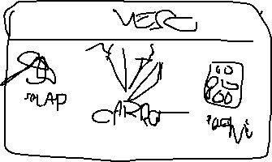

# Acceptance Criteria

* Shop products are displayed.
* Each product has an image, name and price.
* If a product is out of stock, that is indicated.
* Images are optimized and resized accordingly.

# Story: Add to Cart

As a user,

I want to put selected items in a cart,

So that I can order/pay for them.

# Wireframe:



# Acceptance criteria

* A shopping cart is visible
* User can add items to the cart
* User can see items in the shopping cart
* User can remove items from the cart
* Number of items in the cart is updated accordingly (increased or decreased).

# Story: Register User:

As a user,

I want to have an account,

So for register user, am not so sure about the **description**.

For add to cart, I though of adding a condition where items stay in cart even if user **logs out** – maybe later?

So that I can select items and order them.

# Wireframe:

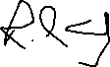

# Acceptance criteria:

* User cannot make payment unless they are registered.
* User can surf to the registration page
* Registration **form** is available with the required fields
* User is successfully registered with the **correct** credentials.

**NB:** I thought of other criteria’s but we’ll discuss about them later